Port of Skamania County

Minutes of Board of Commissioners
January 20, 2026

In Attendance: Commissioner Taylor, Commissioner Kingston, Director - Pat Albaugh, Finance Manager – Cindy Bradley, Facilities Manager – Doug Bill, Auditor – Monica Masco, Attorney Seth Woolson (Zoom), Minute Taker – Annette

Absentees: Commissioner Broughton

Guests: None

Call to Order: Commissioner Kingston opened the meeting at 5:00pm
Public Comment: Cody Rosander updated the Commission on the wrap up of the Cascades Ave Utility Project. Public comment closed at 5:04pm.
Changes to the Agenda: No changes.

Annual Election of Officers:
Commissioner Kingston welcomed newly elected Commissioner for district 2, Commissioner Andrew Taylor and then introduced the annual election.

--MOTION—Commissioner Kingston made the motion; Commissioner Taylor seconded the motion to nominate Commissioner Kingston as President, Commissioner Taylor as Vice President, and Commissioner Broughton as Secretary. Motion passed unanimously.

Commissioners Appointed to Local Boards:
Commissioner Kingston proposed revisiting two- year rotational terms for Commissioners representations on external boards/committees, noting this was used in the past and would help Commissioners gain broader familiarity with partnering entities operate during their six- year term.

Commissioner Taylor made the motion; Commissioner Kingston seconded the motion to nominate Commissioner Broughton to serve as Port of Skamania representative on the Skamania County EDC Board and Commissioner Taylor to serve as Port of Skamania representative on the WPPA Board of Trustees. Motion passed unanimously.

Consent Agenda: The following items were presented for Commissioner’s approval. (Consent agenda items are intended to be passed by a single motion to approve all listed actions.)

- Consideration of the Minutes
- December 16, 2025 Minutes

- Consideration of Pre-issued Vouchers $19,052.39
22838-22839
EFT 01/05/2026-01 thru 01/05/2026-05
Dated: 01/05/2026

(Checking) 22840-22854 $98,822.29
Dated: 01/07/2026

- Consideration of General Fund Vouchers $59,917.92
22855-22869
EFT 01/20/2026-01 thru 01/20/2026-10
Dated: 01/20/2026

- Approval of CORRECTED Pre- Issued Vouchers
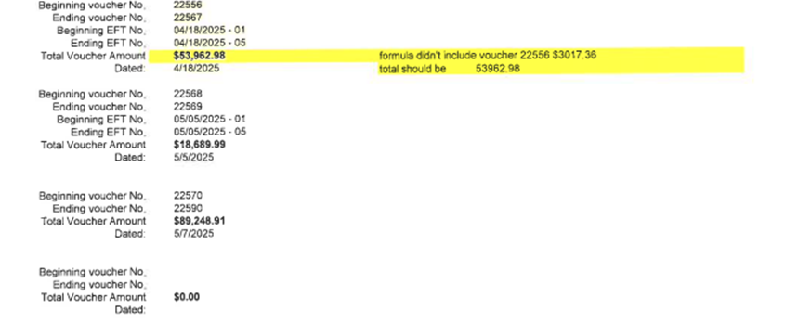

Approval of CORRECTED Voucher Approval

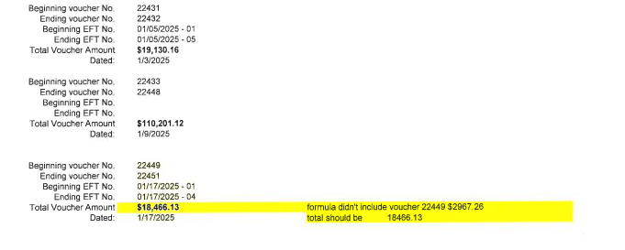

- Resolution 1-2026: Authorizing Pay Albaugh and Commissioner Kingston to sign checks.

- Resolution 2-2026: Approval of Pre-Issued General Fund payment of claims not to exceed $1,000,000.

- Resolution 3-2026: Authorizing Pat Albaugh, Monica Masco, Cindy Bradley, and Commissioner Kingston to order Investment of Funds.

- Resolution 4-2026: Appointment of Director Pat Albaugh as agent to receive claims for damages per RCW 4.96.020.

- Resolution 5-2026: Acknowledging and Setting Port Commissioner Compensation rate for $360 monthly salary and $161 per diem per RCW 53.12.260 (2).

- Resolution 6-2026: Authorizing Director Pat Albaugh to Sell and Convey surplus property less than $10,000.

- Approval of 2026 facility use fee waivers for Farmers Market, Bridge of the Gods Kite Fest, Bootleggers Car Show, Nch’i-Wa`na Challenge boat race, and the Waterfront Music Festival.

Consent Agenda Approval
Commissioner Taylor introduced a motion to approve the consent agenda, including specific amendments to two items. The amendments entailed designating Commissioner Kingston as a signer for item #5 and authorizing Commissioner Kingston as an investor of Port funds for item #7. Commissioner Kingston seconded the motion. All in favor. Motion passed unanimously.

Commissioner & Staff Reports

Attorney’s Report: Welcomed new Commissioner Taylor with no other report.

Finance Manager’s Report: During the report, Cindy Bradley provided an update on the Port’s financial status at year-end. She noted that the overall financial performance was positive. Property tax revenues were slightly lower compared to the previous year. Significant variances in the financials were primarily attributed to the prepayment of the Tower Co. lease and the absence of any major projects underway at this time. Additionally, Cindy reported that all tenants are current on their accounts except for Knucklebusters and Skunk Brothers, who remain outstanding.

Facilities Update
Doug Bill provided a comprehensive update to the Commission regarding the status of several Port buildings. He reported ongoing water issues that have been impacting these facilities. According to Doug, the recent heavy rainfall, combined with construction activities related to the Cascades Avenue Project—which involved significant work on local water mains—are likely contributing factors to these problems. In addition, Doug confirmed that all Christmas lights have now been taken down for the year, ensuring the properties are clear of seasonal decorations.
Doug concluded his report by informing the Commissioners about an upcoming inspection by the Department of Labor & Industries (L&I).

Commission Update: No Commissioners updates.

Executive Director’s Report: Pat updated the Commission on the Stevenson Landing Project, noting the permit will cover railing replacement. He has requested quotes from railing providers and stressed the need for an Environmental Engineer on-call for oversight. The SEPA process for aquatic weed removal is complete and awaiting review before submission.

New Business & Administrative Approvals

- Consideration of Resolution 7-2026 Authorize Pre-Issued Vouchers Retroactive

Commissioner Taylor introduced a motion to adopt Resolution 7-2026. This resolution authorizes retroactive pre-issued vouchers for the calendar year 2025, totaling $1,000,311.41. Commissioner Kingston seconded the motion. All in favor. Motion passed unanimously.

- Consideration of Resolution 8-2026: Amending the Port Personnel Manual

Commissioner Taylor made a motion to adopt Resolution 8-2026 Amending the Port Personnel Manual. Commissioner Kingston seconded the motion. All in favor. Motion passed unanimously.

- Consideration of Resolution 9-2026 Amending its bylaws to change the time of its regularly scheduled meetings

Commissioner Taylor introduced a motion to adopt Resolution 9-2026, which proposes an amendment to the Commission's bylaws regarding the scheduling of regular meetings. Under this resolution, the Port of Skamania Commission will hold its meetings on the second Thursday of each month at 1:00 PM. These meetings will take place at the Port office. Commissioner Kingston provided a second to the motion. Motion passed unanimously.

- Consideration of approval: Re-statement of Teitzel leases to reflect changes in utility charges and billing for the following: Spehros Environmental Sciences & Data (Four Peaks), Correna Smith, Skamania Lawyer, Pacific Crest Trail Association

Commissioner Taylor introduced a motion to approve the re-statement of the Teitzel leases, which reflect updates to utility charges and billing as presented to the Commission. Commissioner Kingston seconded the motion. Motion passed unanimously.

- Consideration of approval- EDC quarterly report

Commissioner Taylor made amotion to approve the EDC quarterly report as presented. Commissioner Kingston seconded. Motion passed unanimously.

- Discussion of Skunk Brothers Spirits Inc

Executive Director Pat provided an update regarding a request from Skunk Brothers Spirits Inc. for financial relief. Skunk Brothers is currently working with local investors to explore additional funding opportunities. The Commission directed Executive Director Pat to continue discussions with Skunk Brothers, specifically to develop a potential payment plan. The Commission requested that Pat present any proposed arrangements at a future meeting for further consideration.

Adjourned: Meeting adjourned at 5:48 pm

APPROVED BY: ______________________________________________
Commissioner Ray Broughton, Secretary (District 1)
______________________________________________ Commissioner Andrew Taylor, Vice President (District 2)

_____________________________________________
Commissioner Todd Kingston, President (District 3)

ATTEST: _________________________
Annette Sabourin, Minute Taker

